Introduction to Support Vector Machines with Python
Abstract
With computing power increasing, more and more intelligent algorithms have been used to classify data. One of the most popularized Machine Learning algorithms is the Support Vector Machine (SVM). This technique finds an optimal solution space that segregates classes based on their features in a dataset. SVM has been utilized for solving various pattern recognition and classification problems in many fields. Yet, the use of this technique in psychology is still unpopularized. One possible reason is the misconception that it is too complex to understand and/or implement. This tutorial aims at demystifying this technique by elaborating more on what is an SVM, how it functions intuitively and how to implement it in Python. Furthermore, it dives deeper into the mathematics behind the SVM. This tutorial is divided in following fashion: an intuitive introduction to the SVM, a guide on how to implement it in python, a detailed explanation of the mathematics behind SVM and a short discussion.

Intro
Thanks to technological advancements in both hardware and software as well as the democratization of computing resources, Machine Learning (ML) has become the de facto approach for data analysis. Both in research and in industry, the power of ML has been leveraged successfully in a plethora of domains and the problem of supervised classification is considered practically solved.
Before the more recent advent of neural networks and Deep Learning methods more generally, Support Vector Machines (SVM) most often provided peak performance when it came to supervised classification tasks. While nowadays they might not always provide state-of-the-art performance, for many applications they remain highly-performant and they remain much easier to design and implement by non-specialized analysts.
The emergence of SVM goes back to the late seventies (Vapnik, 1979), but was popularized only during the late nineties due to data storage and computational power limitations. It progressively became widely accepted and utilized for solving various pattern recognition and classification problems in many fields (Burges, 1998; Suykens & Vandewalle,1999; Lutz, et.al, 2010). These include text categorization and face recognition (Joachims, 1998; Guo, Li, & Chan, 2000), condition monitoring, diagnostics, and medical imaging, (Mourao-Miranda, Bokde, Born, et.al, 2005; Widodo & Yang, 2007), gene and protein selection and analysis (Guyon, Weston, Barnhill, & Vapnik, 2002) as well as the continued application to neural networks and artificial intelligence (Asfaram, Ghaedi, Azqhandi, & 2016).
In Psychology however the use of the SVM particularly and machine learning algorithms more generally,remains scarce and is rarely (if at all) taught at the graduate level or in advanced undergraduate statistical courses.Oftentimes, this results from an over-estimation of the mathematical complexity behind the algorithm, the lack of out-of-the-box statistical software providing SVM functionality or the lack of resources and training to implement pre-built libraries in analysis pipelines through programming languages. Thus, the purpose of this tutorial is to provide an introductory to the basic concepts behind SVM and to help beginners with no prior knowledge to implement this intelligent algorithm in Python.

Background
Statistical applications in psychology most often fall within the domain of descriptive and inferential statistics. Traditionally, once individual-level data is gathered and cleaned, it goes through a series of statistical models and tests such as ANOVAs, T-tests, ANCOVAs, to determine if there are significant differences between groups of participants and whether those patterns would hold beyond the specific dataset at hand.
However, these methods fall short when it comes to classification, i.e. determining if an individual data point pertains to one of the sampled groups based on its specific characteristic, or features. For example, traditional methodologies might allow to determine whether subpopulations suffering from depression are statistically different form those suffering from anxiety (based on answers from a questionnaire, biofeedback measurements, etc) based on specific statistical assumptions. On the other hand, a classification algorithm, can tell you whether a specific individual is more likely to be suffering from depression or anxiety, or more generally, how accurately an intelligent algorithm (with its own set of assumptions) can discriminate between the two disorders.
Such algorithms fall under the family of supervised learning algorithms. Simply, this means that in order to tune the statistical parameters used for classification (what is called the training phase), it uses a subset of data in which not only the features of individual data points (i.e. survey/emotional score, biometrics) are known but also the class (i.e. disorder) to which they belong. From there, it iteratively, attempts to find the best fit that best respects the restrictions of the known data...
T For example, the SVM
Mathematically, in this test, each participant is represented by an input feature vector and its corresponding target class as an integer identifier. For illustraion purposes, consider this simple 2D classification task in figure 1, where the training dataset is represented by 20 individuals (the individual dots)that pertain to one of the two classes (represented here as a binary variable), black or yellow. The x and y axis represent two arbitrary numerical features (e.i., stress and anxiety score). Simply put, the goal of the SVM is to create a line that would separate the two classes with the least number of points from one class on the side of the other class. This separating line is referred to as the decision boundary, since it can later allow us to label new data points, with unknown class depending on which side of the line they fall.

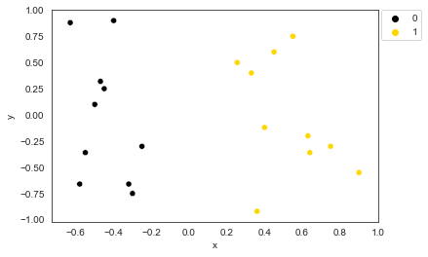
- Simple 2D linear classification task.
While here we chose an example with only two feautres (the x and y measures), for illustration purposes, SVMs can operate in higher diensional spaces, for which one wouldn’t be abe to visually determine the decision boundary. While for a 2D task, this boundary is a line, for a 3D task it would be a plane and for an nD task it is referred as a hyperplane.
As seen in figure 2, if one were tasked in drawing arbitrayr decision boundaries for the xample in figure 1,quickly one would realize that there are various possible decision boundaries that can separate the training set in the two classes. The question then becomes which one does it best?
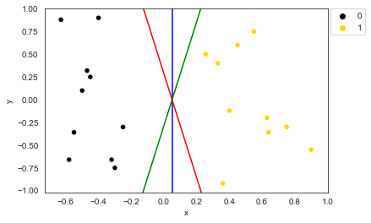
- Various possible decision boundaries to classify both classes.
To solve this, an SVM defines the best classification boundary as the one that leaves the largest distance between the two classes. SVMs are not unique in such an approach. Linear Discriminant Analysis for example, would assume the data classes to be distributed according to Multivariate Gaussian distributions and determine the decision boundary as the hyperplane that maximizes the (standardized) distance between means (or Mahalanobbis distance). What makes SVMs such a powerful tool in comparison, is that it does not impose assumptions on the data distributions.. Instead, it seraches for the data points that are closest to the opposite class, known as support vectors. The goal of the SVM is to find those support vectors resulting in the widest margin or gap between the two classes. The decision boundary then becomesthe middle point of the two class hyperplanes (figure 3a). Once the decision boundary is found, any new instance can be classified by looking at its location on the feature space, i.e. on which side of the decision boundary it is located (figure 3b). In other words, the SVM learns to perform a classification task by iteratively testing data points as support vectors and picking those that leave the widest distance between classes, thus finding the optimal decision boundary
a)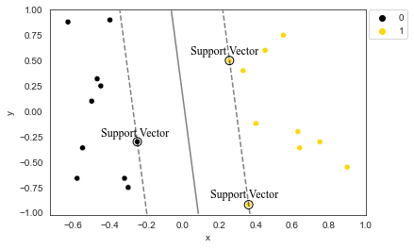 b)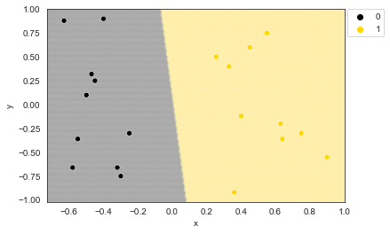
- A) SVM’s decision boundary (straight line) definition from class hyperplanes (dotted line) and support vectors (circled dots). B) SVM decision zones, in the black zone everything will be classified as 0 while in the yellow zone as 1.
WE SHOULD HAVE A SECTION FIRST THAT SHOWS THE RELAXED SVM. AS IN AN SVM CLASSIFYING OVERLAPPING CLASSES.
So far, the data illustrated has been linearly separable, which means a single straight decision boundary is sufficient to classify the dataset. However, this might not be the case for real world data. Often, a problem can be non-linearly separable. In such a case, the solution might require a curved decision boundary or even multiple decision boundaries. Figure 4 illustrates a simple non-linearly separable task with 2 features (x and y) and 2 classes (yellow and black). As it can be noted, no single straight hyperplane can be used to adequately separate the two classes. Intuitively, we know that the classes can be separated by a circular boundary between them. However, how does one reconcile this intuition with the theory presented thus far.
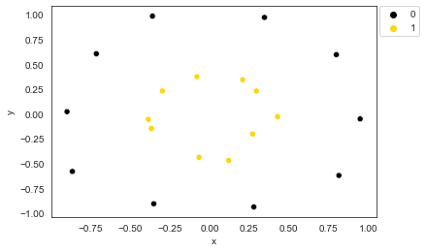
- Circular dataset
Fortunately, the SVM can learn to classify non-linear tasks by using the kernel trick. Essentially, this method permits to project the input feature vectors into (infinitely) higher dimensionsy and use this augmented feature space to find a linear decision boundary following the same general procedure described for linearly separable cases. Figure 5 visually illustrates this process.
YELLOW DOTS IN THE MIDDLE ONE ARE REALLY HARD TO SEE
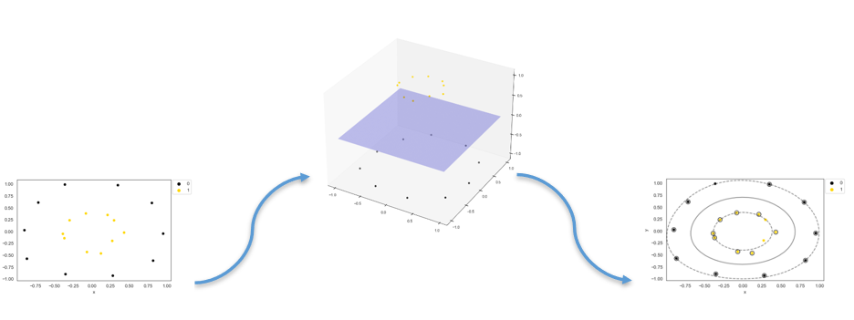
- SVM’s decision boundary (straight line) definition from class hyperplanes (dotted line) and support vectors (circled dots).

We see that while there is no hyperplane that can separate the 2D representation of the data, if one were to elevate the yellow dots on a third dimension, it would suffice to draw a hyperplane between the two classes. Any point in the 2D space can then be classified, which would result in a decidion boundary as een in the last panel. The specific algorithms that allow a computer to perform this type of operation with arbitrary datasets is beyond the scope of this introductory tutorial. For those interested, a quick overview is provided at the end of the document. Instead, in the following section, we show how one can implement an SVM in Python using the popular machine learning library SciKit-Learn (https://scikit-learn.org/stable/) which takes care of all the mathematical and implementation concerns. This should serve as both a learning example and template of non-linear data classification for novel users, with limited Python and machine learning experience.

A guide to SVM in python
To implement the SVM in Python, we will use Scikit-Learn. This handy library comes installed with Anaconda and contains many pre-built classifiers and machine learning algorithms (see Rolon-Mérette, et al. for a simple installation tutorial). This section will consist of a step-by-step implementation of an SVM in Python using an arbitrary 2D non-linear dataset, the same as illustrated in figure 4, and a more complex dataset with many features (multi-dimensional).

To begin, we import the necessary libraries and packages, as shown in figure 6. Shortly, Numpy is useful for implementingmathematical operations in array-like structures. Pandas [pandas is not necessary in this tutorial. We could remove it to slim dependencies, or keep it because that’s where data will come from most times anyway] allows for inputs and results to be stored in organized table-like datasets. Seaborn [seaborn is most often imported as sns] and Matplolib are great visualization libraries. The SVM package contains the SVM classifier, and the datasets package contains a vast amount of different classification and non-classification sample datasets. Both are found within the Scikit-Learn (sklearn) Library.

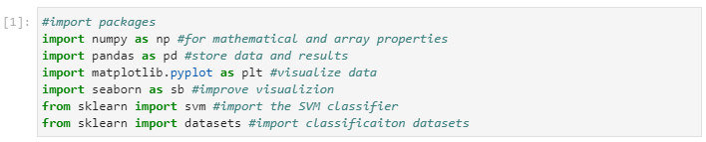
- Import libraries and packages.

We create our first dataset using the make_circles function from Scikit-Learn. This creates two circles (one within the other), each representing its own class. The different parameters control the shape and size of the dataset. This dataset will be stored in the X input matrix (the collection of indivdual input feature vectors) and the Y vector (the collection of target numercial identifiers). This will serve as the training set [should actually use the train-test split to check accuracy afterwards] that will be presented to the SVM for it to find the optimal decision boundary. The two class labels are 0 or 1. [we should use a lot morethan 20 points and maybe more noise too to make it more realistic]

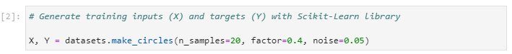
- Import training inputs

Optionally [this seems unnecesary], to better view the dataset, we can store the inputs and targets into a Pandas Dataframe. This assembles the dataset into a table-like manner and eases many processes like visualization, accessing and storing. This is first done by creating a pandas dataframe for the inputs (df_X) and targets (df_Y) separately and then joining them together in df_inputs. We can then view a sample of the dataset using the function head( ).
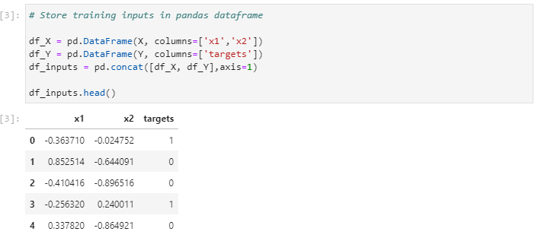
- Store dataset into Pandas Dataframe

Since the data is two-dimensional, it is always good practice to first visualize it in order to get any potential hints that will help with the classification. For clarity, we plot the points corresponding to each class with a different color.
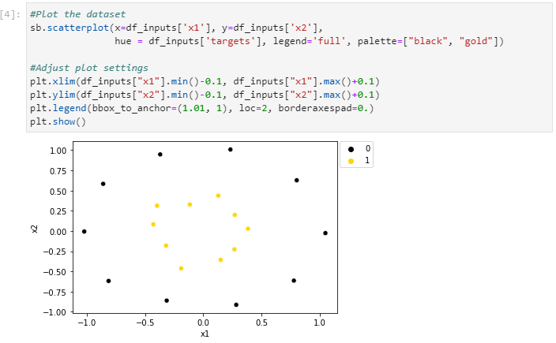
- Visualize a dataset using Matplotlib and Seaborn.

We can now train the SVM for classification. The first thing to do is to initialized the imported SVC class by passing a few argumentsSince it is already imported via Scikit-Learn, we can just call it with svm.SVC and its function fit to train the SVM on the inputs (X) and targets (Y). We can store this SVM in a variable, called SVM, to easily access it later. There are many parameters to the svm package, one interesting is kernel which defines which kernel to use. For this tutorial, we will use the rbf (Radial Basis Function) kernel, but there are several others. For a more in-depth explanation for all the SVM parameters, please visit the Scikit-Learn website (https://scikit-learn.org/stable/modules/svm.html). [you are testing perforance on the trainng set]

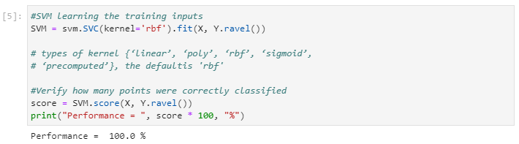
- SVM learning of training inputs.

After training the SVM, we can test whether the dataset has been correctly classified by using the score function. This will yield the SVM’s performance on the training inputs. As shown, with a performance of 100%, the SVM has correctly classified all inputs. Furthermore, we can also infer what class it would predict from a new input. For example, say the SVM received the input (1, 1), which would visualize to be in the top right corner in figure 9. Clearly, this input belongs to the “0” (or black) class. To evaluate if the SVM can determine this, we can use the predict function on this new input. As shown, the SVM’s “prediction” is that the class of the input is 0.

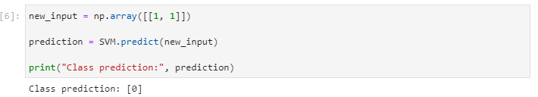

While predicting a new output is useful, it would be even more interesting to observe what is the decision boundary of the SVM. To do this, test inputs can be used to evaluate what the SVM would predict as their class labels. These test inputs can also be used to determine the decision boundary of the SVM. Thus, we create these test inputs using meshgrid, a package included in Numpy that will evenly space out the test inputs between preset values (the lowest and highest x and y coordinates found in the training inputs). The distance between each input, or step size, is given by the parameter h. A low value of h will yield a higher number of test inputs and a smoother and more precise decision boundary. A high value of h will yield a lower number of test inputs and a rougher and less precise decision boundary. To ensure that the h is small enough, we can set it at about 100 times smaller than the width of our dataset distribution. The test inputs are then stored in a Pandas Dataframe.
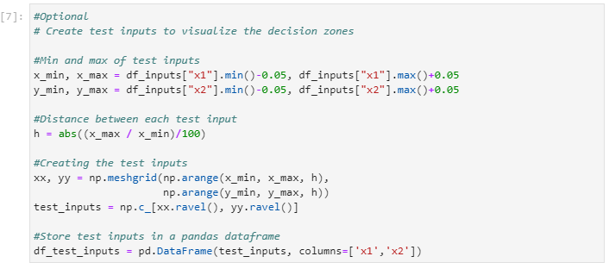
- Creating test inputs.

Subsequently, the predict function can be used on the test inputs to determine the decision boundary. First, the results, or predicted labels, are stored in a variable, predicted_labels, and it is then subsequently stored in a Pandas Dataframe along with the test inputs.

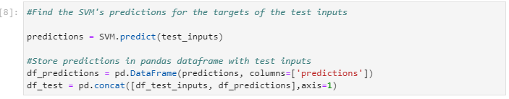
- SVM predictions on test inputs.

Finally, we can plot the decision boundary using Seaborn and Matplotlib to visualise the decision zones that the SVM has learned to represent for each class.
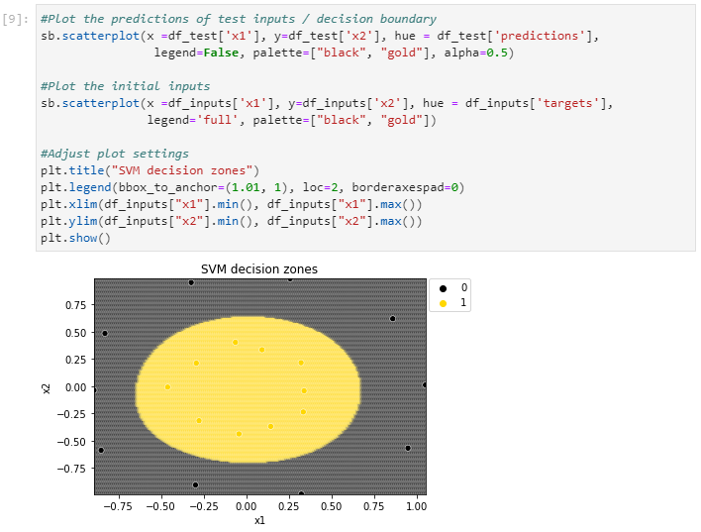
- Decision Boundary on test inputs.

As it can be noted, implementation of the SVM in Python requires just a few lines of code. This makes using the SVM in python very simple and gives access to its classification power by the click of a button. This is not only applicable to 2D datasets, but to bigger, more “realistic”, datasets as well. In the Scikit-learn library, there are many such datasets provided to test, practice or evaluate a model. One of such is the breast cancer dataset, which contains 589 inputs with 30 features for a malign or benign tumour. This data set can be imported using the same“datasets” package already used for the previous task. We can store the inputs in a variable X and the targets in a variable Y.

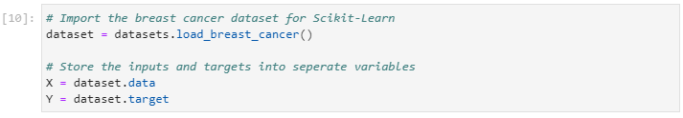

Once again, to get an organised view of the dataset, we can use a Pandas dataframe. As previous, this step is optional. We can print the length of the dataset to see that there are 569 inputs with 30 features. We can use the .head() function to see the first five inputs.
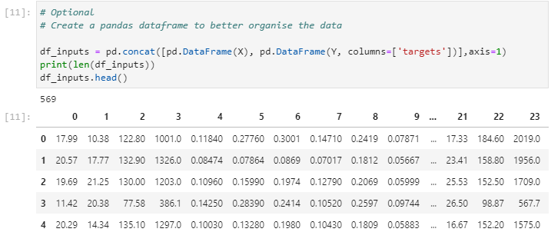

To train and evaluate an SVM on the new dataset, the same steps as in figure X can be done. First, we create the SVM (in this case with an “rbf” kernel) and then train it on the dataset with the fit function. Subsequently, with the score function we can observe that the SVM has correctly classified around 92% of the dataset.
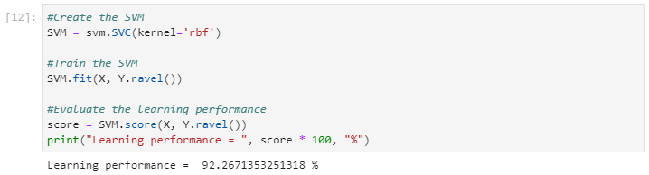

Although a classification performance of 92% might seem decent, it would be desirable to achieve 100% performance. Thankfully, the SVM package form Scikit-Learn comes with many parameters that can be changed and tuned to a specific task. Once such a parameter is gamma which can be manually set to any value. Essentially, the gamma parameter influences whether “closer” or “further” points are considered important by the SVM. Although such parameters fall outside the scope of this tutorial, for a more in-depth explanation, please see https://scikit-learn.org/stable/auto_examples/svm/plot_rbf_parameters.html#:~:text=Intuitively%2C%20the%20gamma%20parameter%20defines,the%20model%20as%20support%20vectors. Thus, by setting the gamma parameter to 1, we can achieve 100% classification performance on the breast cancer dataset.
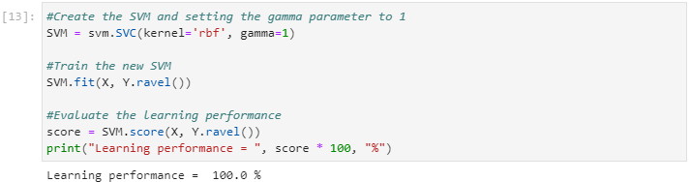

The math behind SVM
Notation
We first define an individual data point or measurement by the row vector x:
x=x1 xj xF
Each element xj represents the magnitude of feature j=1,2,…,F with F being the total number of features. The x vector can be thought as a data point in an F-dimensional space F⊆CF and most commonly F⊆RF. We call F the feature space. The training set is composed of N individual measurements, which we can index by the letter i =1,2,…,N and arrange them in table form such that the training set can be written as:
X=x1 xi xN =x11 x1j x1F xi1 xij xiF xN1 xNj xNF
In our example, a vector xi refers to an individual dot (either blue or red) with its two associated features (x and y, F = 2). In the context of a binary classifier, we define the class label for data point xi as yi=-1, 1. The label of a data point is an arbitrary representation of the class, i.e. 1 (blue) or -1 (red). The training dataset of N measurements is therefore defined as the pairs:
x1, y1,…,xi, yi, …,xN, yN
We can concisely define the training set and individual classes as:
Xy=X y =x1 y1 xi yi xN yN
Hyperplane Geometry
SVM performs its operations based on class and boundary hyperplanes. It is necessary then to first define them in mathematical terms. A hyperplane can be fully defined by a vector perpendicular to its surface, what is called its normal vector w and an offset scalar value c in the general equation for a plane:
w=w1 wj wF
⟺w∙x=c
Where represents the dot-product between the two vectors. For simplicity, the dot product notation will be dropped and considered implicitly.
⟺wx=c
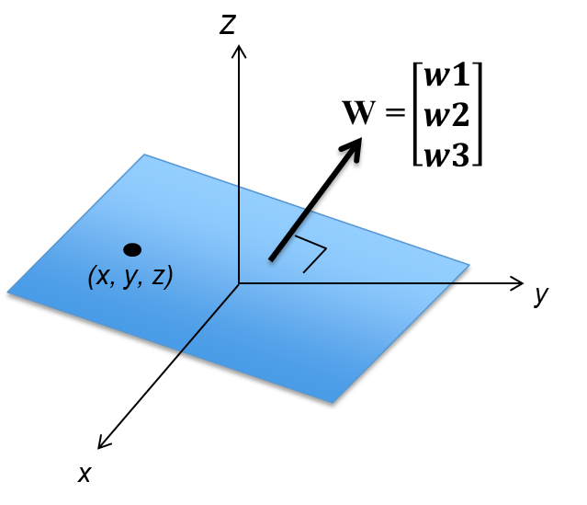
- Definition of a hyperplane by its normal vector w
We can see how such definition of a plane is sufficient by taking the example of a hyperplane in 2D space, a straight line:
wx=c
w1 w2 x y =c
w1x+w2y=c
y=-w1w2x+cw2
y=mx+n
Before finding the decision boundary, each class must be represented by a hyperplane. For each of the two classes of the training set data, we define the hyperplanes -, +, which respectively correspond to class yi=-1 and yi=1:
-: w-T x-=c-
+: w+T x+=c+
For the SVM to work, a few restrictions must be imposed. The first is that the hyperplanes are to be parallel:
-+
w-w+
We further assume the normal vectors to be equal and pointing in the direction of the positive class:
w-=w+=w
We also impose the following restriction on the offset constants:
cy=yi-b
Where b is a shared constant across hyperplanes. Given these restrictions, the hyperplanes can be concisely defined as:
y: wx+b=y
From these two hyperplanes, the decision boundary 0 is simply:
0: wx+b=0
Since w points in the direction of the positive class, any point above 0 is part of the positive class and any point under 0 is part of the negative class. Therefore, the classification criteria for any new point xi becomes:
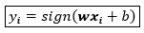
The specific value of w and b however needs to be found for each specific data set. The process of finding their specific values is called parameter optimization. The next part of this tutorial explains how to find the specific w and b that would allow to classify the data with the classification equation.
Optimization – Training the SVM
SVM tries to classify new data by defining the decision boundary that leaves the most space between classes. In this case, our first optimization condition is that the distance between y or margin must be the greatest possible. To find this distance, we can use something called a projection (figure 5). Essentially, the distance between the closest data points from each class (x, these two points are on - and +) will be projected onto vector W. Sine this vector is perpendicular to the hyperplanes, the projection will result in the distance between the - and +.
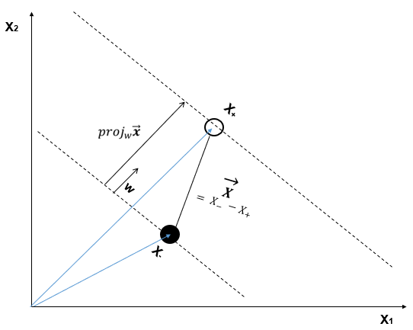
- Visualisation of the projection to find the distance between two planes
Once again, we can find the distance between the two planes by selecting two arbitrary points x- and x+ from - and + respectively. We define the vector pointing from one of these arbitrary points to the other x=x--x+. The distance between the two planes can be found from the projection to the normal vector:
projwx=xw‖w‖w‖w‖
=xw‖w‖2w
⟺D1, 2=‖projwx‖
=‖xw‖w‖2w‖
=xw‖w‖2‖w‖
=xw‖w‖
D1, 2=x--x+w‖w‖
From the definitions of the planes, we relate the arbitrary points to the normal vector and offset constant:
w xy+b=y
⟺wT xy=y-b
⟺w‖w‖2w xy=w‖w‖2y-b
⟺xy=w‖w‖2y-b
Therefore:
D1, 2=x--x+w‖w‖
=w‖w‖2-1-b-w‖w‖21-bw‖w‖
=-1-b-1-b‖w‖
=-1-b-1+b‖w‖
D1, 2=2‖w‖
Maximizing the distance between the hyperplanes is therefore equivalent to minimizing ‖w‖
For mathematical convenience, this is equivalent to minimizing 12‖w‖2or ‖w‖2 . F or consistency with the literature, we will use 12‖w‖2.
Therefore, the optimization condition given by the maximization of the distance is equivalent to:
arg12‖w‖2 L
This equation essentially means that across all possible values of w and b, we want to minimize the magnitude of w. This optimization equation consists of a quadratic, or convex, problem. This is a good thing because there will only be one optimal solution, so the SVM will not get stuck in a local minimum and will always find the global minimum (correct solution).
Maximizing the distance between classes is not sufficient by itself to appropriately define the decision boundary. Indeed, if applied on its own, the optimization of w would just set two hyperplanes at an infinite distance from each other and the data would simply fall in between the two planes. One can also notice that the optimization criteria does not consider the value b defining the hyperplanes. Moreover, an additional problem with the unique optimization condition is that the minimum would be obviously found at w=0 which would make no geometrical or practical sense in our problem.
The additional restrictions necessary to find w and b depend on the distribution of the specific training set. For all practical purposes, the distribution and respective optimization problem fall under one of the following three categories: (1) linearly-separable data, (2) almost linearly-separable data and (3) non-linearly separable data.

Linearly Separable Data – Hard Margins
Hard margins are applied when the data is linearly separable, which means that the classes are distributed in such a way that the decision boundary can be drawn between the two classes and all points of each class are found in their respective side of the decision boundary.
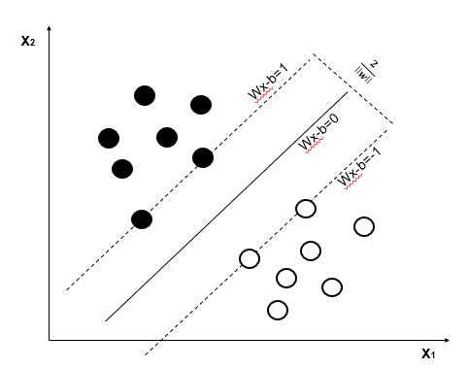
- Hard-margin classification by the SVM.
Mathematically, the condition that all points must be on the right side of the decision boundary is defined as:
yi= -1 ⟺wxi+b≤-1
yi= 1 ⟺w xi+b1
Or more concisely:
yiwxi+b1 ∀ i ∈1,…,i,…,N
For the hard-margins categorisation, the class hyperplane lies on the data points closer to the decision boundary. These points are called support vectors (hence the name Support Vector Machine). Fun fact, you only need a few support vectors to classify an entire dataset.
The full optimization problem for linearly separable data therefore becomes:
arg12‖w‖2 , s.t. yiwxi+b1 ∀ i ∈1,…,i,…,N
Each type of SVM (linear, near-linear, non-linear) is essentially an optimization problem. Depending on the SVM type, the optimization problem changes slightly. The next section of this tutorial will dive into building a linear decision boundary with a less strict classification rule, where an arbitrary amount of error will be accepted.

Linearly Separable Data – Soft margins
The assumption behind the previous linear classifier is that the two classes are clearly divided within the feature space. But it is often more common to find overlap between the two classes as seen in figure 7
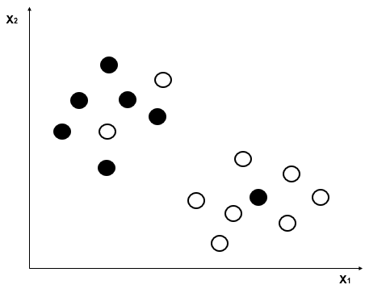
- Near-linear classification problem.
While in this type of situations a linear divider could not be used, SVMs can be effective if we introduce a slack variable . This variable represents the importance of the error of a data point or how deep the data point is in the other class’ territory, as seen in figure 8. We can calculate the total errors as the sum of the individual errors and add them to the optimization problem. :
arg12‖w‖2 +ii, s.t. yiwxi+b1-i ∀ i ∈1,N
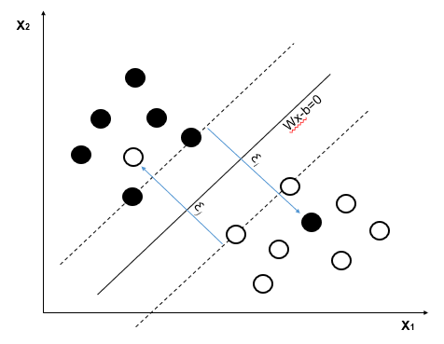
- Soft-margin classification.
The parameter determines the importance we attribute to the errors. This is chosen by the data analyst for each specific situation at hand, depending on how lenient one can be about accepting errors. If we want to minimize them, a large value of will get us to the hard-margin situation (where no errors are allowed to happen). On the other hand, a low value will be more lenient and at the extreme values of 𝜆, it will stop considering the data altogether.
If data point i were to fall on the right side of its class’ support vector, we would expect the slack variable to be 0, independently on how far in its class’ territory it is. Also, the furthest away the data point is inside another class’ territory, the higher we would want i to be. We therefore define i as the “hinge loss” function:
i=max0, 1-yiwxi+b
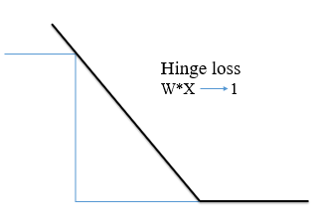
- Hinge loss function representation.
We can then rewrite the optimization problem as:
arg12‖w‖2+imax0, 1-yiwxi+b

Non-linear classifier
The previous definitions assume that the two classes can be separated linearly (or allow small errors). Rarely data is distributed in such a neatly organised fashion. As seen in figure 10, most datasets are arranged in complicated ways.
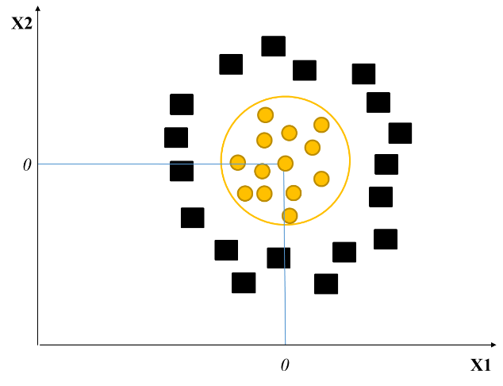
- Non-linearly separable problems.
While SVM could not be applied to classify this type of data, it is possible to apply non-linear operations on the dataset to increase their dimensionality until they become linearly separable. A dataset might be non-linearly separable in its input space (X1 and X2, 2D in this example), but can be mapped (with the use of a non-linear transformation) into a higher dimensionality called the feature space (Z1 and Z1). In this feature space, the dataset will be linearly separable, and a decision boundary can be implemented. Once the decision bound is found, it is mapped back into the input space.
In sum, this transformation, denoted by x, increases the dimensionality of the measurements to allow the SVM to determine an appropriate decision boundary. Figure 11 provides a visualisation of this process with the following transformation:
xi'=x=xi jxij2
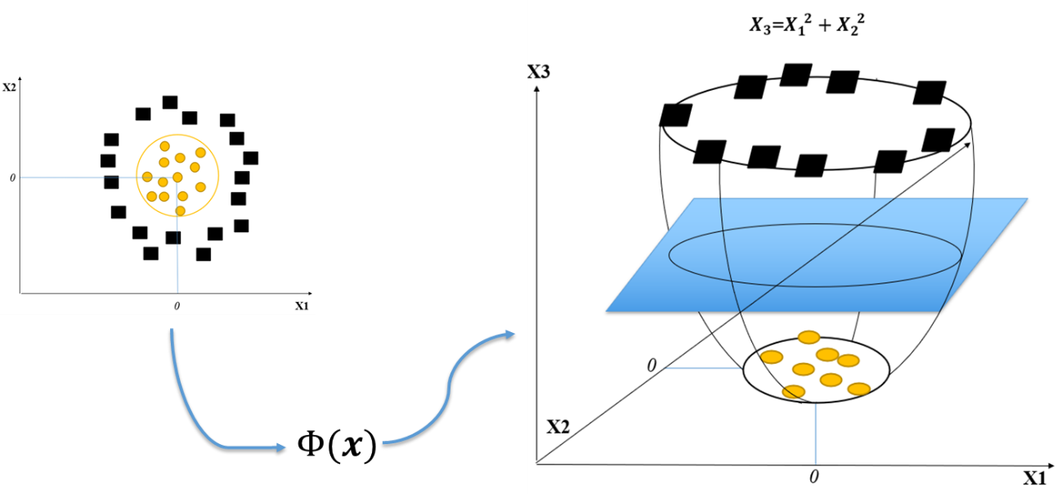
- Transformation on the non-linearly separable distributions to increase dimensionality and allow classification.
It is important to note that all operations of SVM optimization and classification depend on the dot product between two vectors. This is significant because there are mathematical functions that allow these dot products to be done in higher dimensions, without ever going into these higher dimensionalities.
If we were to transform all data points into a higher dimensional feature space, perform the operations and transform them back to its original input space, this would quickly become computationally prohibitive and would limit the SVM to only small datasets. Furthermore, some transformations even require increasing dimensionality to infinity. If that situation would arise, it would be impossible to compute or store such an amount of data.
We can however avoid such problem with the use of Kernels and its functions as shortcuts:
Kx, y=xy
Such a shortcut allows us to perform computations on the higher dimensional space without having to transform the data first. We can illustrate these operations by assuming a simple cubic transformation of 2D space:
x=x1 x2 =x13 x12x2 x1x22 x23
Optimization and classification require dot products as:
xy=x13 x12x2 x1x22 x23 y13 y12y2 y1y22 y23
=x13y13+x12x2y12y2+x1x22y1y22+x23y23
=x1y1+x2y23
We can replace the long computations of the cubic transformation by a polynomial kernel:
xy=Kx, y=xy3
=x1y1+x2y23
Even with such a simple example, we see how we can save on computations. Have we used the direct transformation method, we would have to perform 16 multiplications and 3 sums. On the other hand, the Kernel trick requires us to do only 4 multiplications and 1 sum. Commonly used Kernels are the polynomial Kernel, the Radial Basis Function or Gaussian Kernel and the Hyperbolic tangent (or sigmoid) Kernel. Respectively:
Kx, y=xy+cd
Kx, y=exp-‖x-y‖22
Kx, y=tanhkxy+c with k>0, c<0
The specific kernel to use depends on numerous factors, such as the arrangement of data, the type of dataset or the preference of the analyst.
Discussion
In this tutorial, the SVM was presented as a supervised classifier capable of classifying linearly and nonlinearly separable data. Furthermore, a simple python implementation was shown through the Scikit-learn library. What followed was a detail explanation of the mathematical mechanism behind the SVM, and how it relies on building class hyperplanes by finding support vectors while respecting two conditions: hyperplanes class having the widest distance/margin between them and data points falling on the margin (the support vectors) respecting the restriction of the b variable.
Three types of SVM were presented: the hard margin and the soft margin classifier, that are used for linearly separable data, and the non-linear SVM that uses the kernel trick. In all cases, once trained, a SVM can classify new data points with high accuracy. This being said, there are some limitations to this machine learning technique. A downside to this approach is that in some cases it requires tunable parameters (the C, Gamma and the kernel type). To correctly find the right values for both of these parameters and to avoid overfitting, it seems like for now trial and error are the best options. Furthermore, another down side of the SVM is that it does not deal well with data sets that have the number of features greater than the number of samples.
That being said, the SVM is still seen in general as the most performant machine learning algorithm for classification tasks out there. Additionally, SVM is not only exclusive to classification, but it can also perform regression analysis as well (Smola & Scholkopf, 2004). An important aspect of this method is that it analyses datasets without worrying about any assumptions (homogeneity, normality, etc.). Traditional statistics have always been bound by these assumptions, and while they have proven to be good tools in statistical analysis in the past, interesting alternatives are now emerging in the world of Machine Learning.
This tutorial aimed to introduce the SVM in a simple and intuitive way while also demonstrating the sophistication behind it. The Python implementation was of simple nature to illustrate how feasible it can be to use the SVM in research. Although not mentioned, there are more particular versions of the SVM out there worth exploring. Scikit-learn is a great and simple library where it is possible to find many of these versions as well as other machine learning algorithms, such as artificial neural networks, boltzmann machines, etc.. Furthermore, they elaborate the functioning of each method. Thus it is highly recommended as the next step from this tutorial to leap around in the documentation of Scikit-learn . Lastly, as with all machine learning methods, there exist various tutorial videos that can be used to solidify or even further your understanding. This tutorial has laid the foundation for any new users to continue their exploration and learning process of the SVM. Hopefully, from now on there can be more research using the power of SVM in psychology.
References
Asfaram, A., Ghaedi, M., Azqhandi, M. A., Goudarzi, A., & Dastkhoon, M. (2016). Statistical experimental design, least squares-support vector machine (LS-SVM) and artificial neural network (ANN) methods for modelling the facilitated adsorption of methylene blue dye. RSC Advances, 6(46), 40502-40516.

Burges, C. J. (1998). A tutorial on support vector machines for pattern recognition. Data mining and knowledge discovery, 2(2), 121-167.

Guo, G., Li, S. Z., & Chan, K. (2000). Face recognition by support vector machines. In Automatic Face and Gesture Recognition, 2000. Proceedings. Fourth IEEE International Conference on (pp. 196-201). IEEE.

Guyon, I., Weston, J., Barnhill, S., & Vapnik, V. (2002). Gene selection for cancer classification using support vector machines. Machine learning, 46(1-3), 389-422.

Luts, J., Ojeda, F., Van de Plas, R., De Moor, B., Van Huffel, S., & Suykens, J. A. (2010). A tutorial on support vector machine-based methods for classification problems in chemometrics. Analytica Chimica Acta, 665(2), 129-145.

Mourao-Miranda, J., Bokde, A. L., Born, C., Hampel, H., & Stetter, M. (2005). Classifying brain states and determining the discriminating activation patterns: support vector machine on functional MRI data. NeuroImage, 28(4), 980-995.

Rolon-Mérette, D., Ross, M., Rolon-Mérette, T., & Church, K (2021). Introduction to Anaconda and Python: Installation and setup.

Smola, A. J., & Scholkopf, B. (2004). A tutorial on support vector regression. Statistics and computing, 14, 199-222.

Wang, Z., & Xue, X. (2014). Multi-class support vector machine. Support Vector Machines Applications (Springer), 23-48.

Widodo, A., & Yang, B. S. (2007). Support vector machine in machine condition monitoring and fault diagnosis. Mechanical systems and signal processing, 21(6), 2560-2574.

Vapnik, V. Estimation of Dependences Based on Empirical Data [in Russian]. Nauka, Moscow, 1979. (English
translation: Springer Verlag, New York, 1982).

